Ground Station Antenna Aiming Rig Documentation
by Gautaman Asirwatham
February 21st 2024:
Problem:
Aiming the antennae requires an ability to sense the position of an orbiting satellite and the current orientation of the antenna, an ability to support and actuate antennae movements, and an ability to programmatically apply a controls algorithm to allow for tracking with high precision.
Sensors:
The real-time position data of any NORAD ID satellite, including the ISS, can be accessed using the requests library at http://api.open-notify.org/iss-now.json. We get the latitude and longitude position, from which the angular position in azimuth and elevation can be calculated.
The current orientation of the antennae can be tracked by zeroing around the fully vertical position and incrementing the current position for each action of the stepper motor. Over the system's runtime the incrementally calculated orientation may deviate from the actual orientation. This is mitigated by using motor drivers which can more precisely actuate the antennae. Also limit switches triggered at the fully vertical position may be implemented to allow for periodic recalibration of the antennae orientation.
Movement and Support:
We are using the “A” antennae and the “B” tripod. A mount is needed to securely attach the antenna to the tripod. Two stepper motors will be bought or repurposed to actuate rotation in two degrees of freedom. Motor drivers may be needed depending on the desired responsiveness and stepping resolution. Interfacing parts will be needed to connect the mechanical components of the system while allowing transmission of rotation. A microcontroller is also needed along with a power supply. These hardware components may need to serve other purposes for the ground station, so the details of this setup must be considered by the entire ground station team. Such a system would support the power and processing requirements of multiple systems.

Controls Processing:
A microcontroller is needed such as an Arduino or Raspberry PI. This decision depends on what best suits not only antenna aiming but also the other subsystems. This will send a signal to two motor drivers which then control the stepping action of the stepper motors.
The current orientation of the antennae is compared to the relative angular position of the ISS and a desired angular change is calculated. This is converted into a stepping action for each stepper motor, allowing for tracking in real time.
Upon starting data collection, the antennae must move from the fully vertical “home” position to the current ISS position, before tracking can be performed incrementally in real time.
ISS Tracking Software:
Code tracks any satellite with a NORAD ID and outputs the desired adjustment in degrees and steps. The program uses a feedback control loop and position data from N2yo.com.
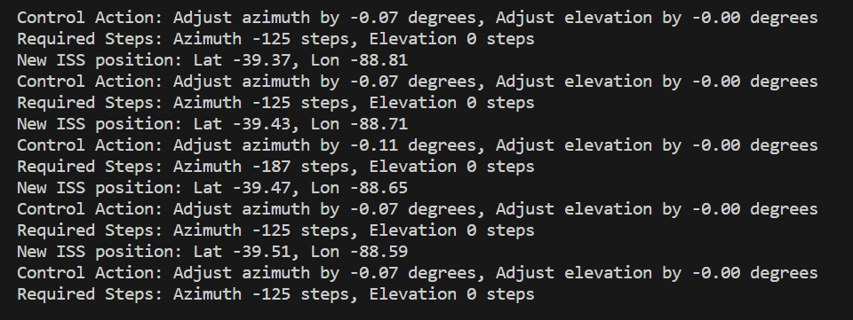

March 6th 2024:
Rig Hardware Design:
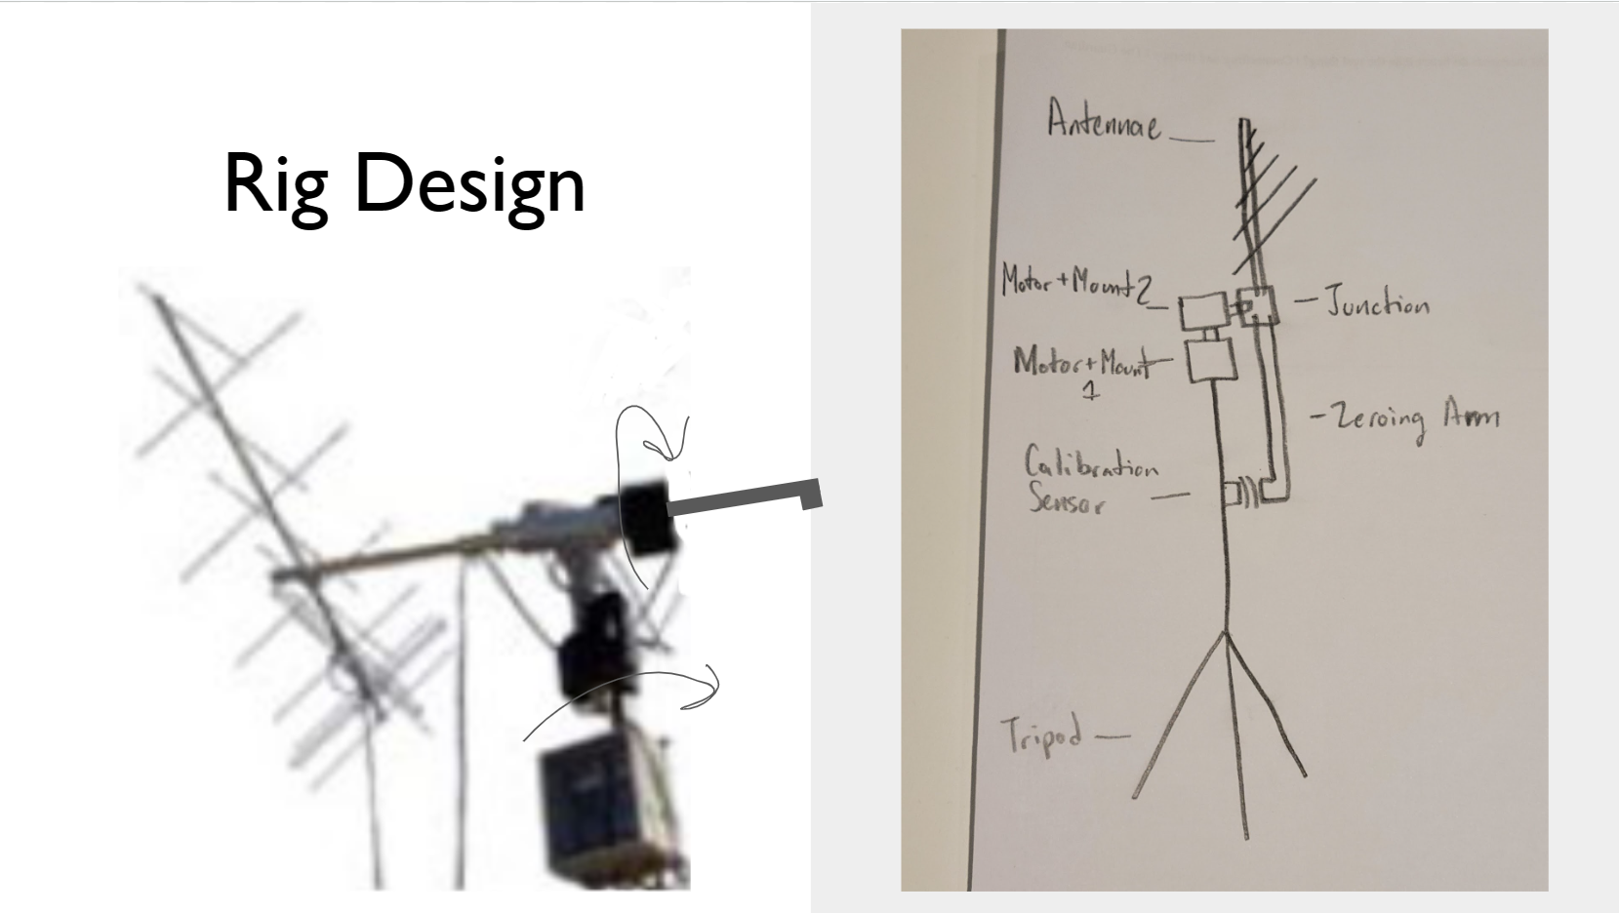
- A (name) tripod provides a stable base for the antennae rig. It will be fully extended to (12?) feet. *needs measurements*
- Mounted on top of the tripod is a motor mount holding a Nema 23 motor. The motor is positioned so its shaft points upwards, controlling the antenna's horizontal rotation around the base.
- Next a motor hub and interfacing piece connects another Nema 23 motor mount and motor perpendicular to the first motor's shaft, controlling the antenna's vertical angle.
- This motor's shaft extends to a motor hub and junction piece which supports the antenna and accommodates a zeroing arm. In its fully vertical or zero position, the antenna points upwards, and the zeroing arm is strategically positioned to trigger an Omron switch along the tripod pole.
- The design of the junction ensures an ample offset, allowing the antenna to rotate unobstructed in all directions—both elevation above the horizon and in a complete 360-degree azimuth circle.
Selecting Hardware:
Our (name) tripod and (name) antenna have been purchased already. Next I needed to select and appropriate motors, motor drivers, and mounts to use. I performed calculations assuming reasonable operating criteria:
Torque Calc Elevation
- Antennae is modeled as a uniform 1 meter long, 5 kg beam. I will design for the case where I cannot precisely pivot about the center but instead 5 cm off.
- Inertia = (1/12)*m*L^2 +m*R^2 = 0.429 kg/m^2
- Torque of gravity = m*g*d = 2.453 N
- For NEMA 17 (Torque = 0.59 N*M): -> NEMA 17 would be insufficient
- For NEMA 23 (Torque = 3 N*M): -> Factor of safety = 1.222

I believe the https://www.omc-stepperonline.com/nema-23-stepper-motor NEMA 23 stepper motor is our best option.
Stepping Resolution
For ISS tracking, the minimum observed angle change per step is 0.06 degrees at a stepping rate of once per second.
The recommended driver for the NEMA 23 is the DM556T Driver

Calculation (NEMA 23 - 200 steps per revolution, DM556T Driver - 1/400 microstepping):
- Effective steps per revolution = 200 steps/rev * 400 = 80,000 steps/rev
- Degrees per step = 360 degrees / 80,000 steps = 0.0045 degrees/step
- Steps needed for 0.03 degrees = 0.06 degrees / 0.0045 degrees/step
13.333 steps
Microstepping is sufficient. Higher resolutions up to 1/25,600 are possible if needed.
Operating speed is not limiting since steps are so small. The operating angular acceleration is likely low so torque requirements depend primarily on resistance due to factors like friction.
Overall the parts suggested are available, affordable, and reliable as supported by their suppliers and distributors.
March 13th 2024:
Required Parts:
Nema 23 Motor (2 of them): Nema 23 Stepper Motor 2.4Nm(339.87oz.in) 4A 57x57x82mm 8mm Shaft 4 Wires - 23HS32-4004S|STEPPERONLINE (omc-stepperonline.com)

6 mm Mounting Flange (2 of them): Bought from Amazon

Nema 23 Motor Mount (2 of them): Nema 23 Bracket for Stepper Motor and Geared Stepper Motor Alloy Steel Bracket - ST-M2|STEPPERONLINE (omc-stepperonline.com)

Digital Stepper Driver (2 of them): Digital Stepper Driver 1.8-5.6A 20-50VDC for Nema 23, 24, 34 Stepper Motor - DM556T|STEPPERONLINE (omc-stepperonline.com)

Omron Switch: D2F-FL Omron Electronics | Mouser

March 20th 2024:
Designing Interfaces:
I needed to design 3 parts, each connecting to other parts:
- Connecting the motor (facing up) to the motor mount (on its side). This must transmit rotation.
  - A central hole shaped to fit around the D-shaft of the bottom motor. A motor hub would be fastened over the hole and around the shaft to ensure a rigid connection and transmission of the motor torque.
  - Mounting holes aligned with the mounting slot pattern of the Nema 23 motor mount. These should be or matched with through holes for nuts.
  - Material thickness sufficient to handle the stress without deforming, yet as lightweight as possible to minimize the load on the bottom motor.
- Connecting (in a junction) the motor (on its side), the antennae, and the calibrating arm.
  - A central hole shaped to fit around the D-shaft of the bottom motor. A motor hub would be fastened over the hole and around the shaft to ensure a rigid connection and transmission of the motor torque.
  - The junction extends out from the shaft before splitting into a T-junction to provide adequate offset for free rotation.
  - The junction is shaped to accept the antennae into its top slot and the calibrating arm into its bottom slot.
- The calibrating arm, connecting to the antennae junction.
  - This arm can be secured into the T-junction holding the antennae.
  - It is dimensioned to trigger the calibrating switch in the fully neutral position.
CAD Parts and Assemblies:
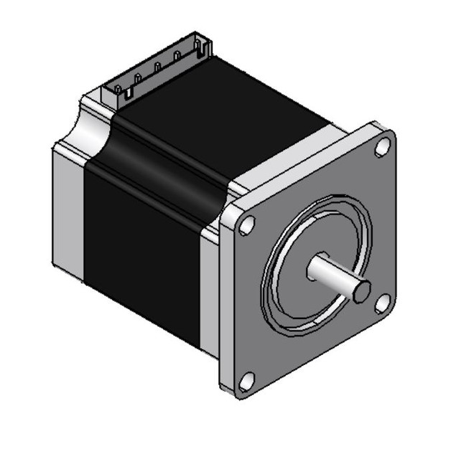
CAD models of the parts I bought were available on GrabCAD:

Step Motor NEMA-23 | 3D CAD Model Library | GrabCAD

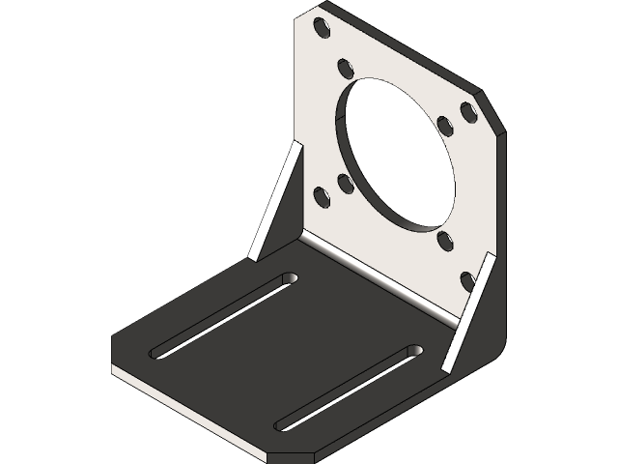

Nema 23 Stepper Motor Mounting Bracket | 3D CAD Model Library | GrabCAD

April 17th 2024:
1: Motor Shaft-Motor Mount Interface
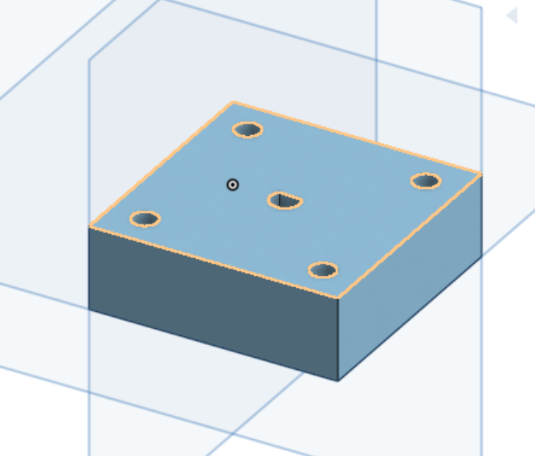
2 and 3 prototype: Junction/Calibrating Arm
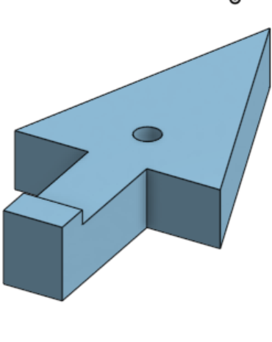
April 24th 2024:
Fabricating Parts:
I decided to 3D print my parts in plastic with 20% infill. These parts were light weight and could be easily drilled into to provide mounting holes for the motor hubs and motor mounting brackets. However, the final rig could likely be improved by using stronger aluminum parts.
Wiring:
The motors, drivers, arduino, and voltage source are shown wired in this picture. I used an Instek 9600 since I needed a voltage in the 20-50V range to power my drivers:
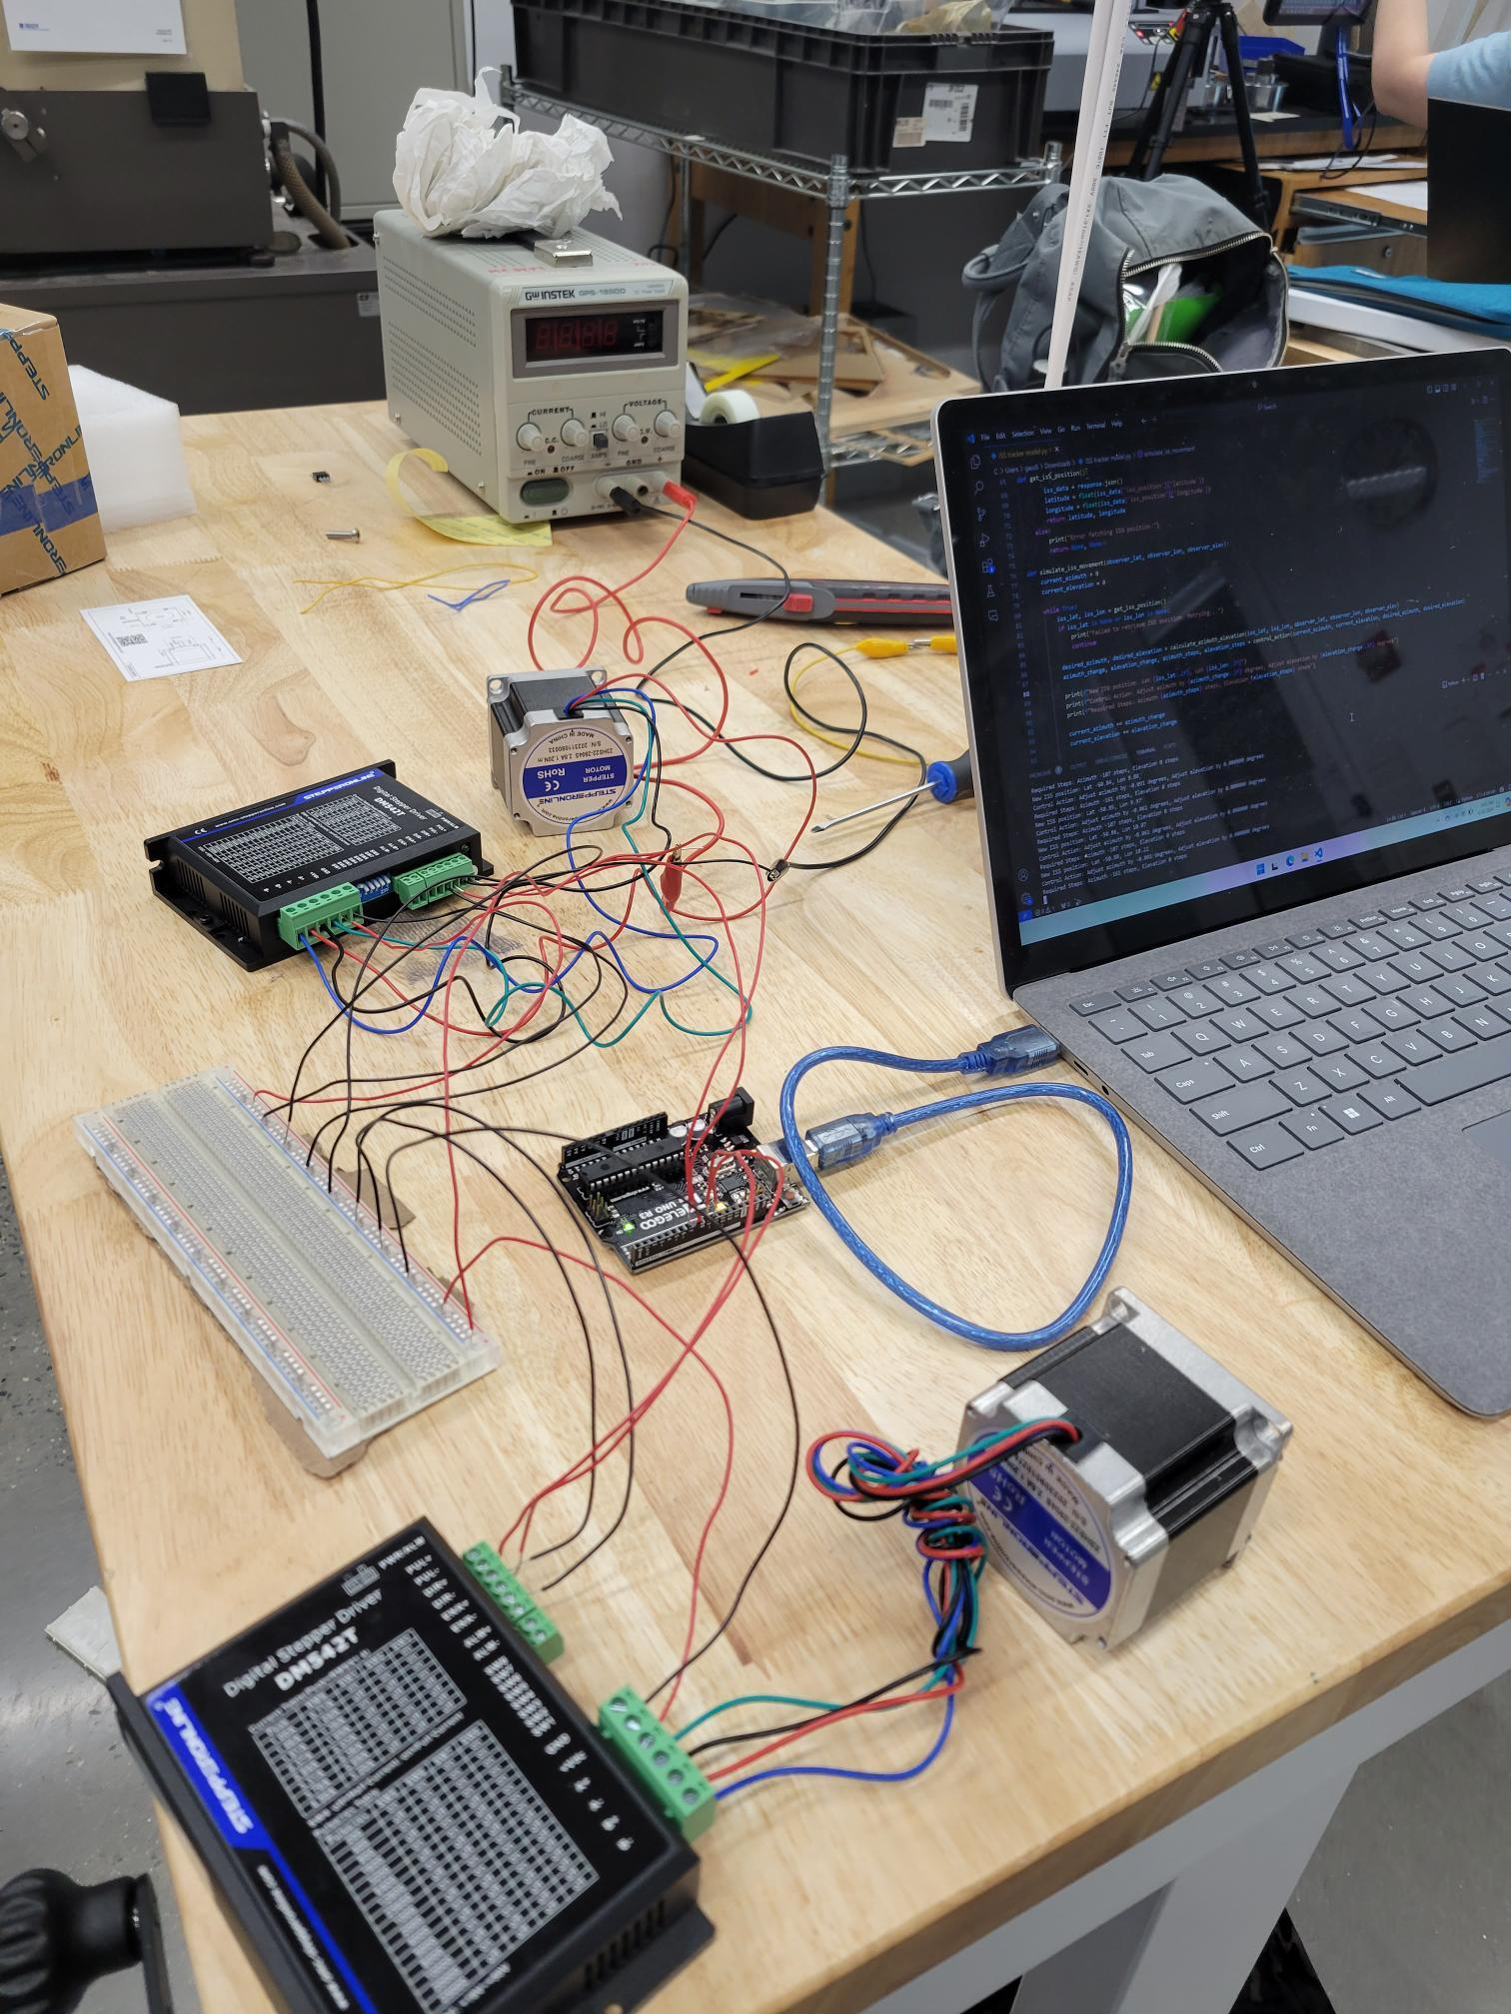
April 24th 2024:
Presentation and Demo:
Together with the rest of the ground station, we presented at the VIP showcase. My demo was able to track NORAD IDs and actuate 2 degrees of freedom with a 3d printed arrow in place of the full antennae.
Next Steps:
The mounting will need to be modified and re-fabricated to support the full antennae. I believe the best option is an aluminum part clamping around the central axis while being thin enough to fit between the barbs.
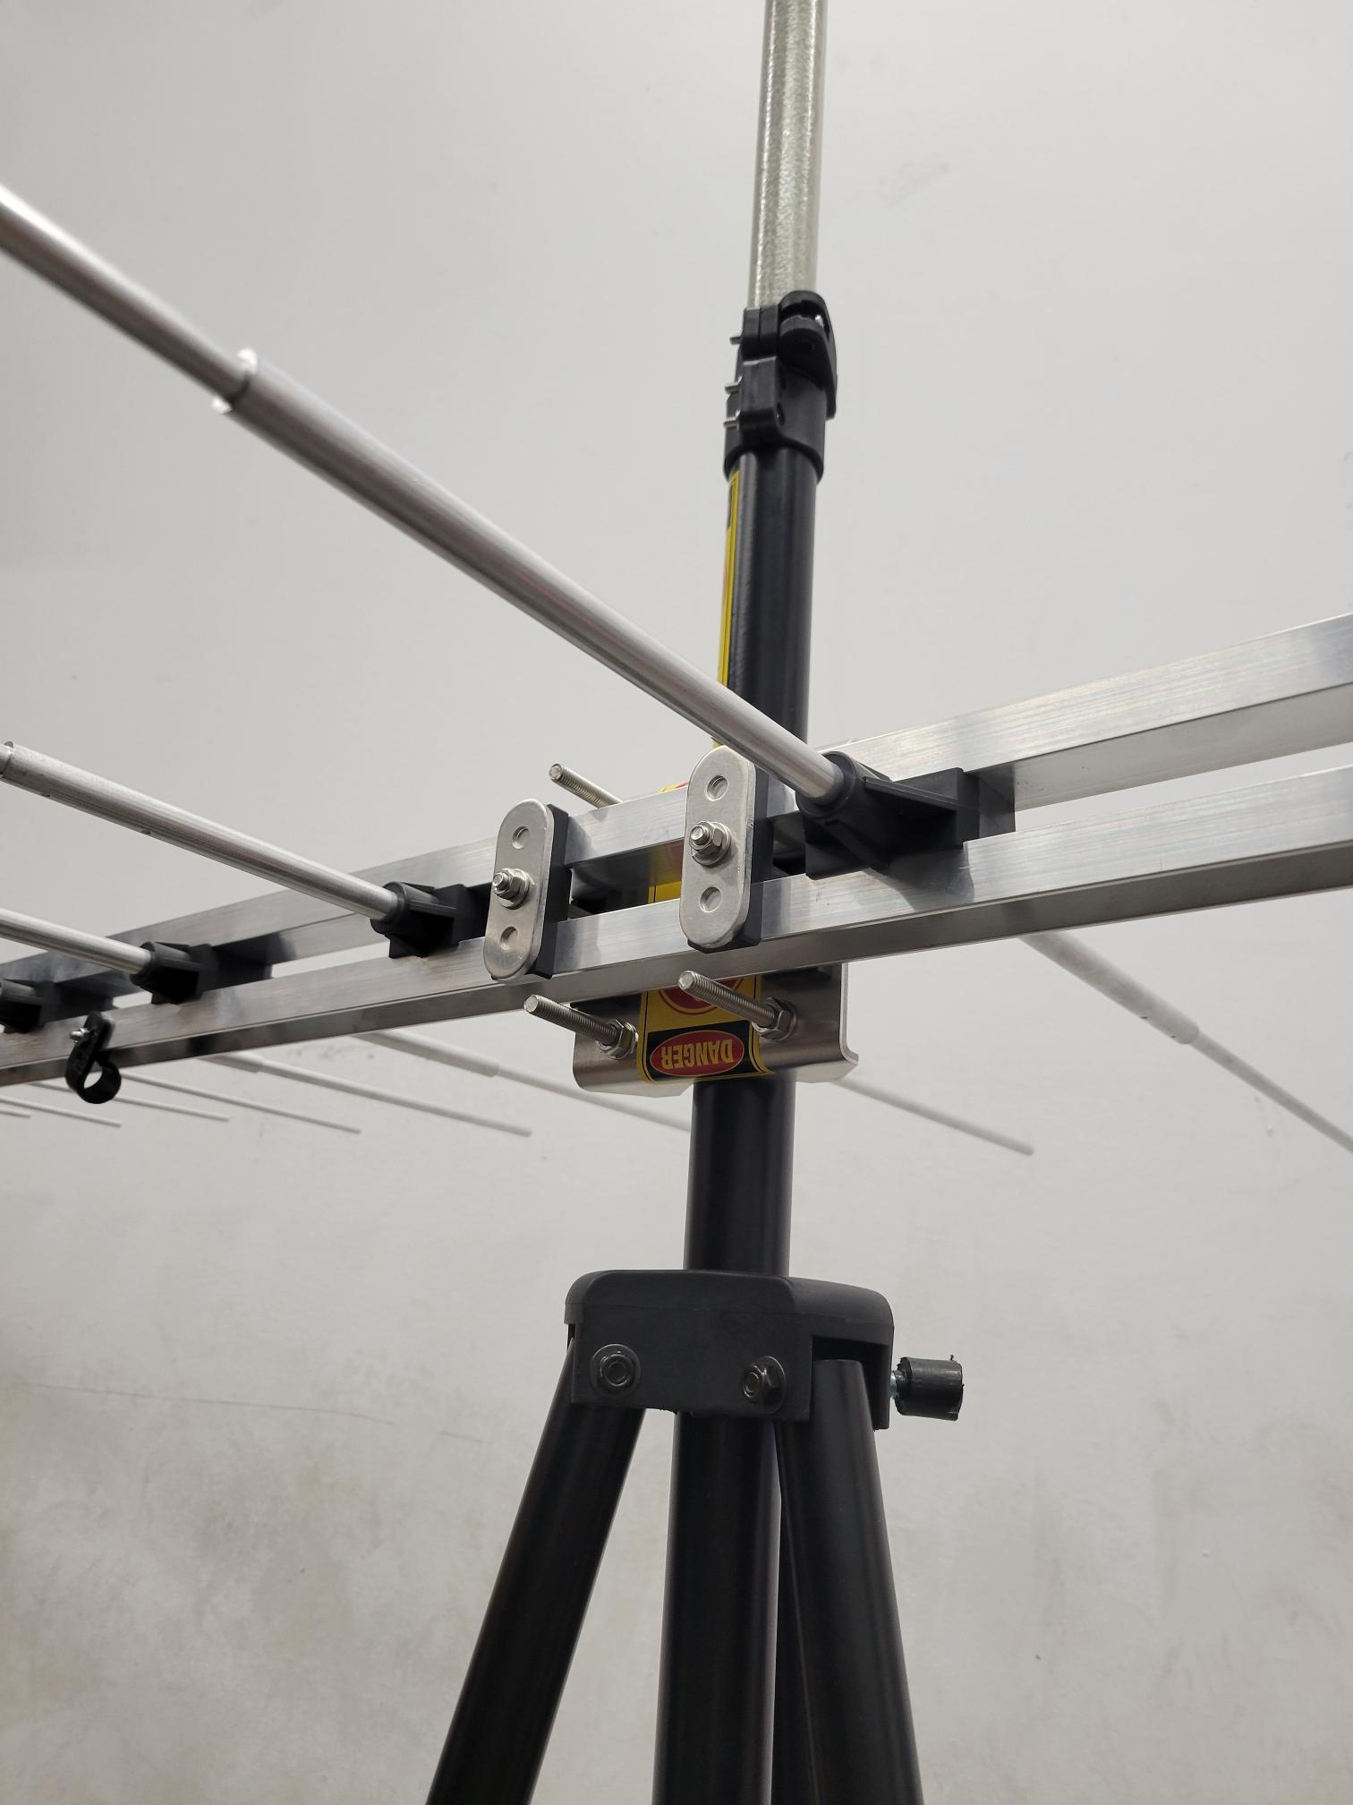
Proposed Testing:
Before mounting the antennae the system can be tested to learn about the following concerns:
- Stability of the system. The stability will be challenged by the asymmetric weight loading, rotation, and wind. We may need a wider base or a counter balance to mitigate this. We also need to determine the best height to operate at to mitigate interference but maintain stability and safety.
- Specifying the degree of precision needed for tracking the ISS and maintaining reception. How precise does the angular position measurement need to be (in degrees or radians)? This will affect how often stepping action occurs and how often we recalibrate our orientation.
- Software features. We may want to make the software functional with weather balloon position data. Maybe even being able to easily switch between weather balloons available at N2yo.com. Also emergency stop features and failure detection.

Written by Gautaman Asirwatham, Ground Station, May 5th 2024

